INSTRUCTIONS
This file contains:
- two templates – one suited to a trades business (page 2) and one suited to a products/services-type business (page 3)
- an example of a completed brief profile as an inserted image (page 4).
Choose the style best suited to your business. The templates have suggested subjects listed in the left-hand column. Fill in the details for your business in the right-hand column. The aim is to be reasonably brief and to keep it to one page (see page 4).
Feel free to change, add to or delete suggested subject areas. What other characteristics of your business would you like to inform your target market about? Other possibilities include:
- vision, mission and/or business philosophy
- the values by which do you do business
- your unique selling proposition – what makes you different or outstanding compared with your competitors
- any awards won or any certifications achieved, e.g. ISO or Australian Standards
- any registrations required to do your work, e.g. builder’s licence, licensed plumber or electrician. Put in category and licence number if relevant, or state that all tradespeople are qualified (i.e. have a relevant trades certificate) and licensed in their particular fields
- the key achievements of your business in assisting its clients
- the benefits to the client of working with your business
- how you add extra value for your clients (value adds)
- other relevant company fundamentals or strengths – corporate social responsibility, research and development, online ordering, commitment to service, turnaround times, quality, workplace health and safety, environmental standards. Many of these may not apply to smaller businesses
- a short list of key personnel.
Other things to consider
- If you have a business logo, you can add it into the header area of the profile page. Set it either to the left or right-hand side using the alignment buttons in the Home ribbon, paragraph section. If you do not have a logo, put in your company name.
- If you have a Word letterhead file, you can copy and paste your profile into it.
- Fill in the footer area of the page with your business details.
- Add some colour. You could use a colour similar to your logo to add some colour to the page. For example, put ‘Brief profile’ in colour and the bold items in the contact details in the footer. You could also put some shading on the table, alternating white with a pale shade. This can be done with the shading tool on the Home ribbon, paragraph section.
- Feel free to change the font used; you might prefer Calibri or Cambria (or another font).
Sending out your profile
Once you are satisfied with your profile, convert it into a PDF using the ‘Save as Adobe PDF’ function in Word (in the ‘File’ ribbon). Use the PDF for emailing to prospects. You don’t want these instructions or other unwanted material in your profile, so either delete items you do not need or save your profile as a new file, delete material, and make your PDF.
Would you like your profile checked?
For a cost of $33 (inc. GST), Professional Word Services will edit your profile, resize and insert your logo (if required), and add some colour as described above. Email your document to us at info@profwordservices.com.au. Turnaround will be same day or overnight (depending on volume).

BRIEF PROFILE
Established
Services
Areas of service
Products
Target market
Clients
Workforce
WHS
Quality assurance
Environment
Capacity
Recent projects
Insurance

BRIEF PROFILE
Established
Services
Areas of service
Products
Target market
Clients
Workforce
Recent projects
Why clients
choose us
Benefits of working
with us
Best achievements
for our clients

If you are a solo trader, you might like to include:
- business background
- educational qualifications/achievements
- previous roles held

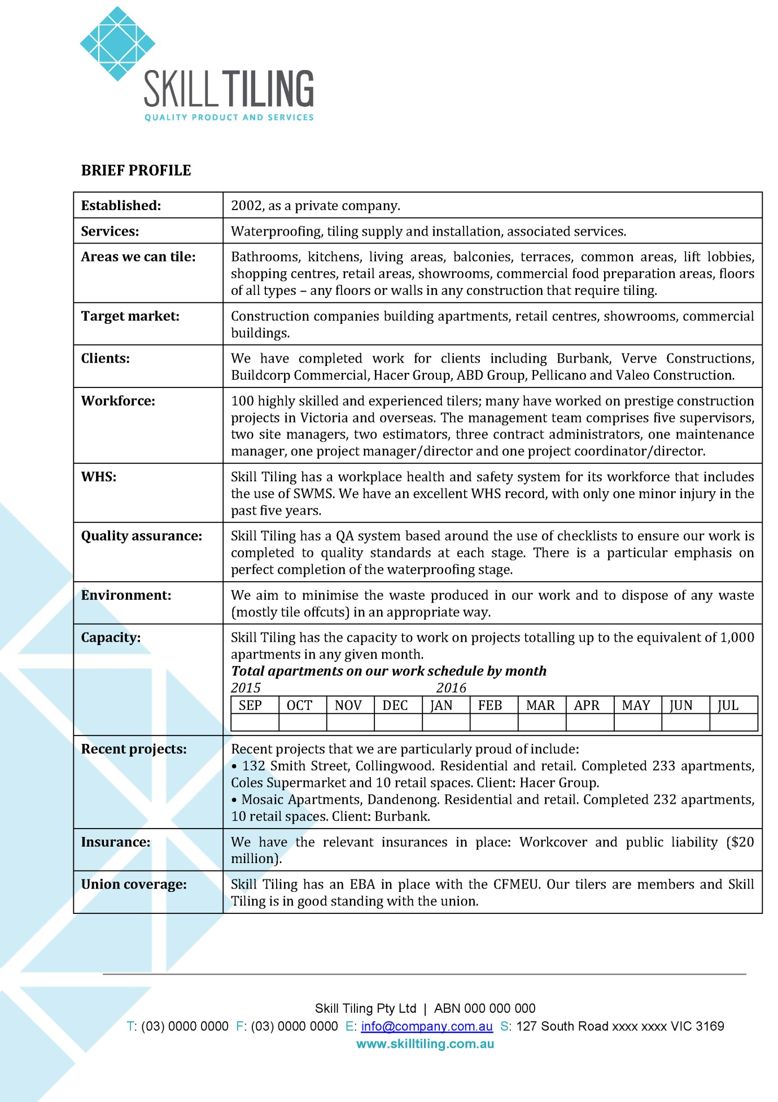

This profile has been placed in the company’s electronic letterhead file. The font used is Cambria.

